Ex.No:9 | MINI PROJECT – FIFA WORLD CUP 2026 PLAYER PERFORMANCE

AIM:
To clean, transform, store, and analyze FIFA World Cup 2026 player performance data using Python, MySQL, Power BI, and Tableau to generate meaningful insights into player performance, team statistics, goals, assists, ratings, and match outcomes.

ALGORITHM:
- Load the FIFA World Cup 2026 player performance dataset using Pandas.
- Clean the dataset by identifying missing values, removing duplicate records, and ensuring data consistency.
- The data by converting match dates and creating relevant performance metrics.
- Store the cleaned and transformed dataset in a MySQL database named fifa_analytics.
- Connect the MySQL database to Power BI for data analysis and reporting.
- Create DAX measures to calculate total players, total goals, total assists, and average player ratings.
- Develop interactive visualizations in Tableau to analyze team performance, player statistics, goals, assists, and ratings.
- Design an interactive dashboard and derive meaningful insights from the analyzed data.
- Conclude the data analysis process.

PROGRAM:

1. Python – Data Cleaning and Transformation
import pandas as pd
from sqlalchemy import create_engine, text

# Load dataset
df = pd.read_csv("fifa_world_cup_2026_player_performance.csv")

# Create a copy for processing
fifa = df.copy()

# Handle missing values
fifa["player_name"] = fifa["player_name"].fillna("Unknown")
fifa["nationality"] = fifa["nationality"].fillna("Unknown")
fifa["team"] = fifa["team"].fillna("Unknown")
fifa["position"] = fifa["position"].fillna("Unknown")
# Remove duplicate records
fifa.drop_duplicates(inplace=True)

# Convert match date
fifa["match_date"] = pd.to_datetime(fifa["match_date"])

# Create derived columns
fifa["goal_contribution"] = fifa["goals"] + fifa["assists"]

fifa["pass_efficiency"] = (
fifa["successful_passes"] / fifa["total_passes"]
)

# Standardize column names
fifa.columns = (
fifa.columns
.str.lower()
.str.strip()
.str.replace(" ", "_")
)

# Display dataset information
print("Original Shape:", df.shape)
print("Cleaned Shape:", fifa.shape)

# Display first five records
print(fifa.head())

2. MySQL – Database Creation and Data Loading

MySQL Command Prompt
net start MySQL80
mysql -u root -p

Create Database
CREATE DATABASE IF NOT EXISTS fifa_analytics;

Python / Jupyter Notebook
username = "root"
password = "YOUR_MYSQL_PASSWORD"
host = "localhost"
port = 3306

# Connect to MySQL database
db_engine = create_engine(
f"mysql+pymysql://{username}:{password}@{host}:{port}/fifa_analytics"
)

# Load cleaned data into MySQL
fifa.to_sql(
"player_performance",
con=db_engine,
if_exists="replace",
index=False,
chunksize=5000
)

print("Data loaded successfully into MySQL.")

Verify Data
result = pd.read_sql(
"SELECT COUNT(*) AS total_rows FROM player_performance",
db_engine
)

print(result)

3. Power BI – DAX Measures

Total Players
Total Players =
DISTINCTCOUNT(player_performance[player_id])

Total Goals
Total Goals =
SUM(player_performance[goals])

Total Assists
Total Assists =
SUM(player_performance[assists])

Average Player Rating
Average Rating =
AVERAGE(player_performance[player_rating])

Average Performance Score
Average Performance =
AVERAGE(player_performance[performance_score])

Total Player of the Match Awards
Player of Match Awards =
SUM(player_performance[player_of_match_awards])

4. Tableau – Dashboard Creation
The cleaned and transformed player performance data was connected to Tableau for visualization and analysis. Multiple worksheets were created to analyze player statistics, team performance, goals, assists, ratings, and other relevant performance metrics.
The individual worksheets were then combined into an interactive dashboard to provide a comprehensive overview of FIFA World Cup 2026 player and team performance.
The dashboard enables users to explore the data interactively and identify meaningful patterns and insights related to player performance and match statistics.
OUTPUT:

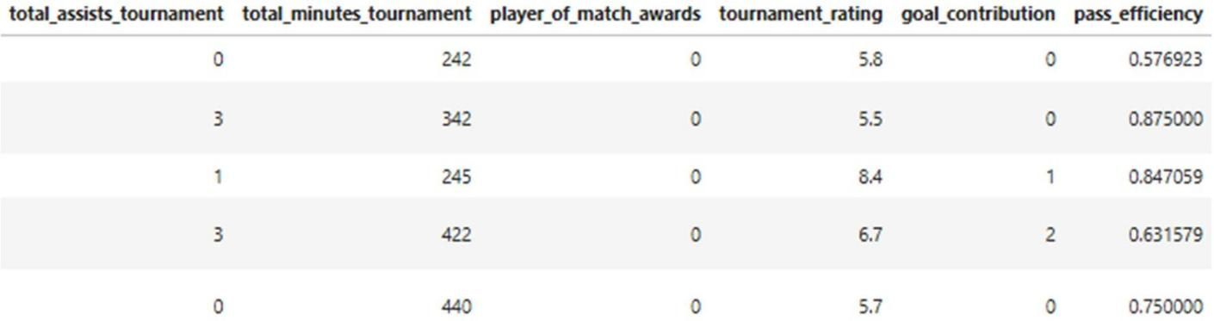
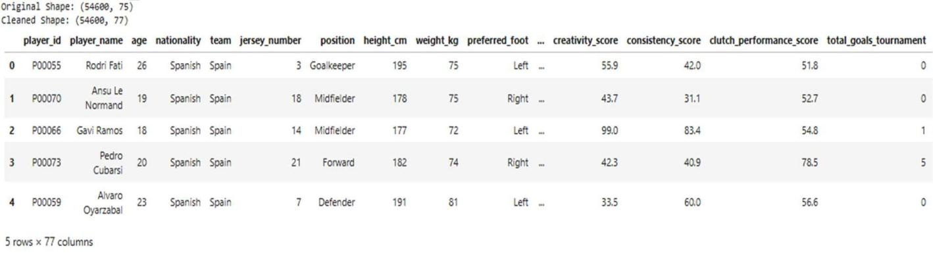

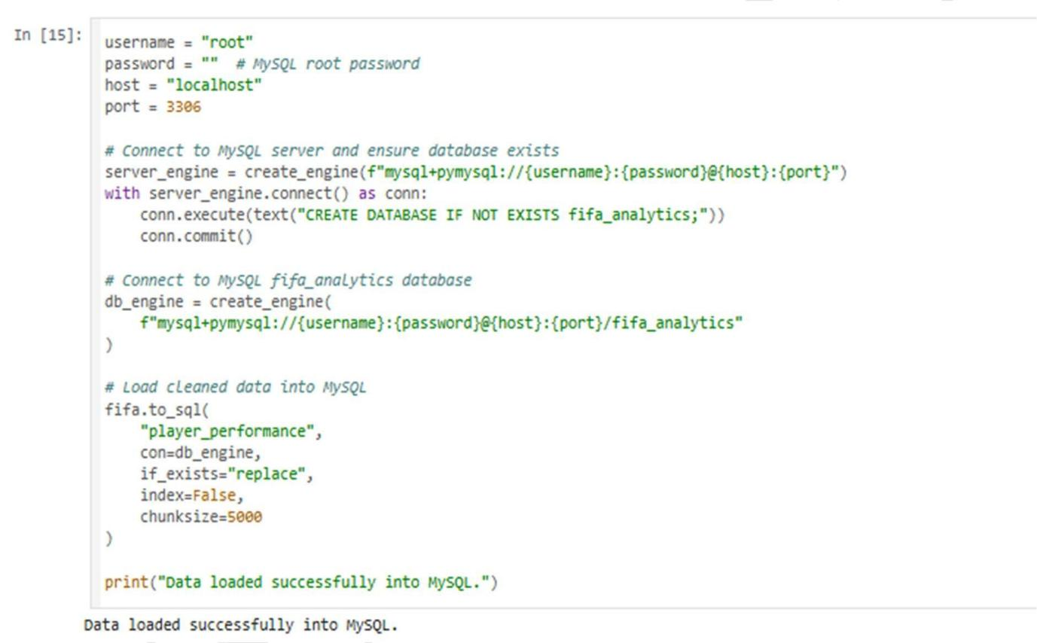

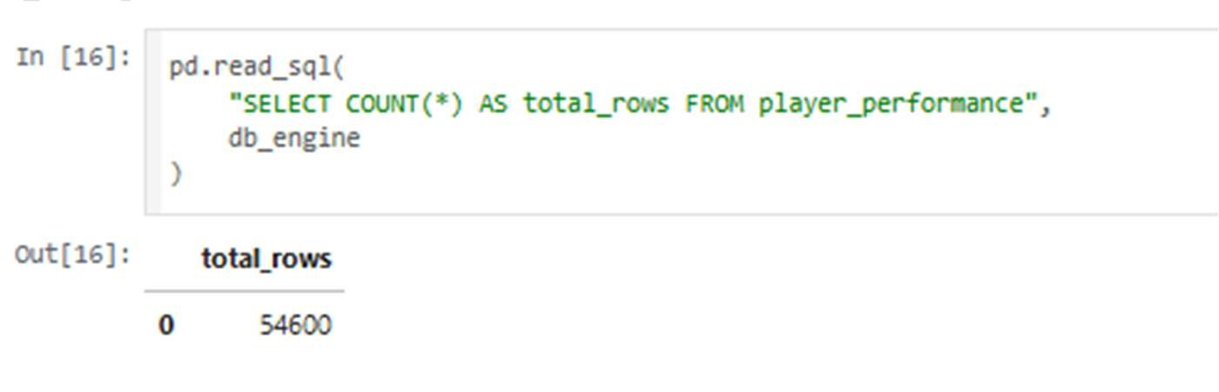
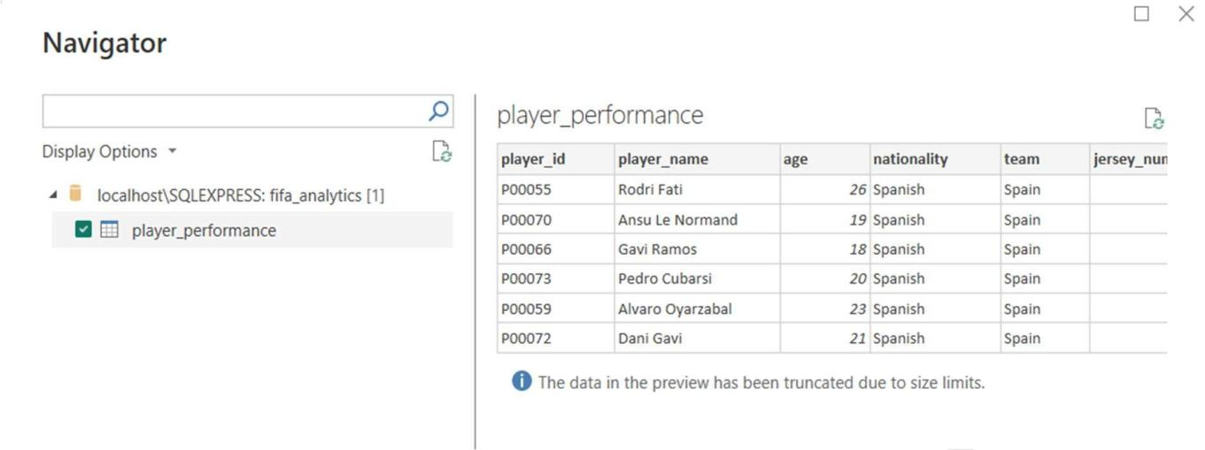

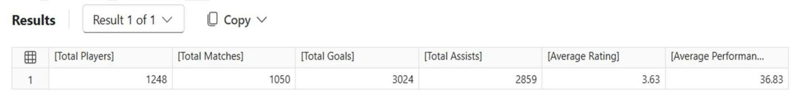

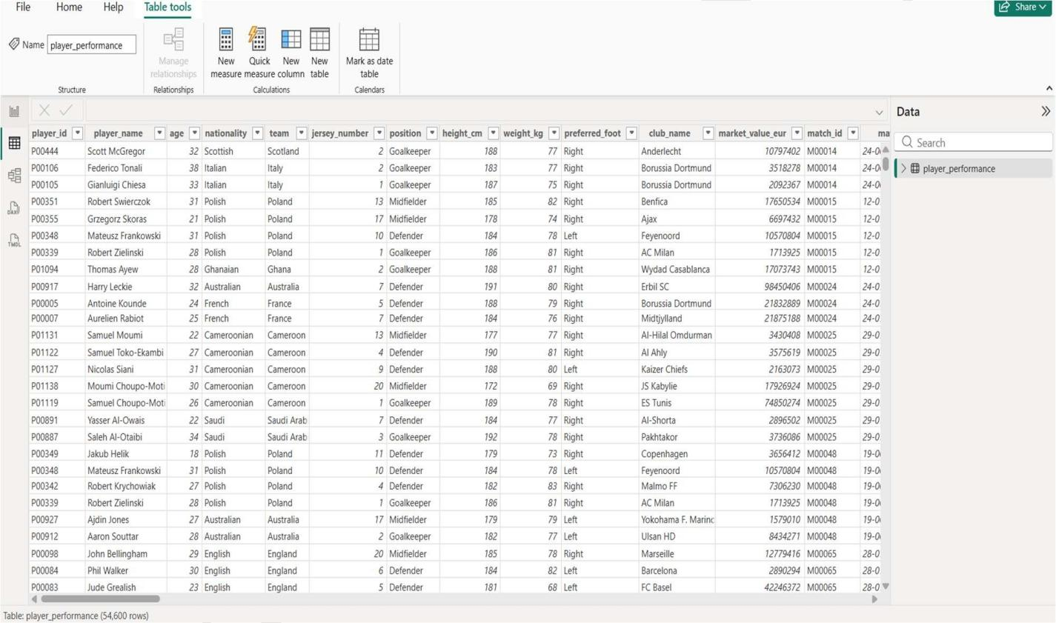

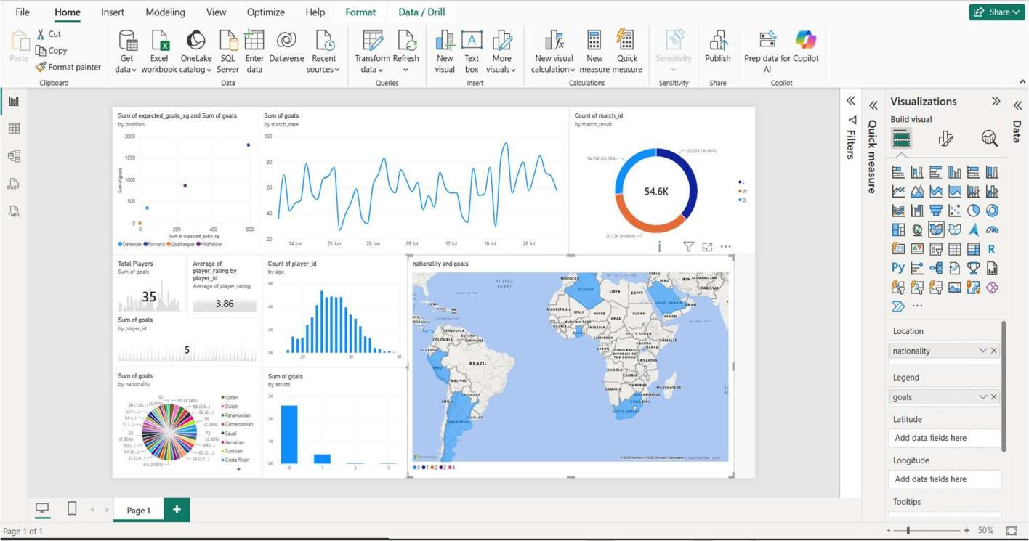

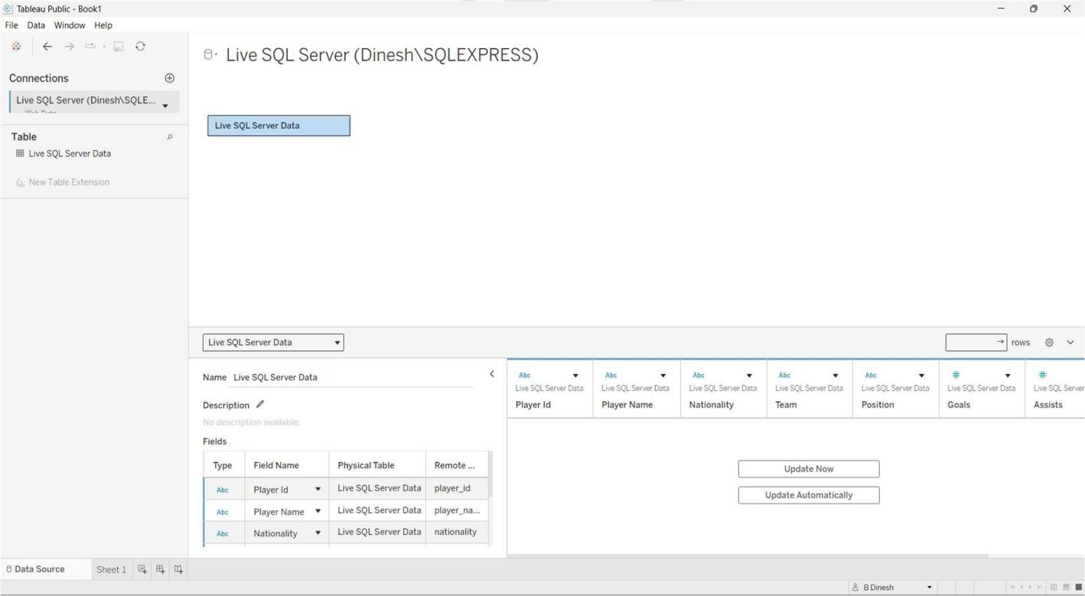

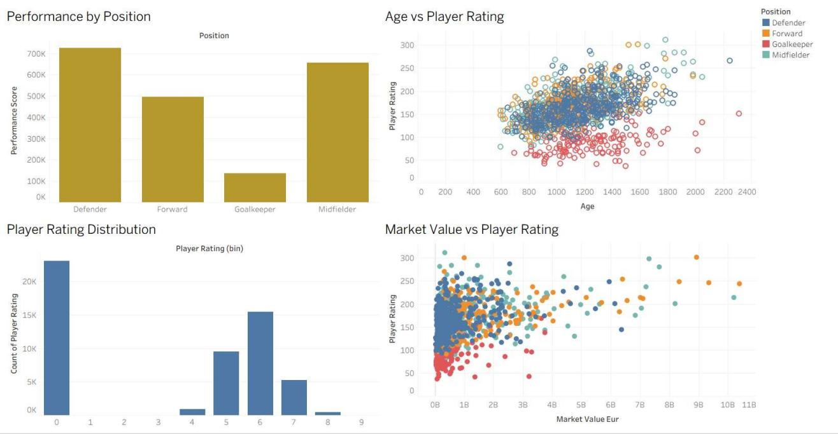

RESULT:

The FIFA World Cup 2026 player performance dataset was successfully cleaned and transformed using Python and Pandas, stored in the MySQL database fifa_analytics, and analyzed using Power BI and Tableau. DAX measures and interactive dashboards were created to evaluate player performance, team statistics, goals, assists, ratings, and match outcomes, providing meaningful insights from the dataset.

